The state of art in AI

The field of artificial intelligence (AI) is constantly evolving, with new breakthroughs and advancements being made on a regular basis. Here are some of the most significant recent developments in the state of the art in AI:

1. Deep Learning: Deep learning is a subset of machine learning that uses artificial neural networks to learn and make predictions from data. This technique has led to major advancements in computer vision, natural language processing, and other fields.
2. Generative Adversarial Networks (GANs): GANs are a type of neural network that can generate realistic images, videos, and other data by learning from a dataset. They have been used to create realistic images of people, animals, and landscapes, as well as to improve data augmentation in machine learning.
3. Reinforcement Learning: Reinforcement learning is a type of machine learning that involves an agent learning how to take actions in an environment in order to maximize a reward. This technique has been used to develop game-playing AI, autonomous robots, and other applications.
4. Transfer Learning: Transfer learning is the process of using pre-trained models to improve the performance of a new model on a related task. This technique has led to significant improvements in natural language processing and computer vision.
5. Explainable AI: Explainable AI (XAI) is a field of research that aims to make AI systems more transparent and interpretable, so that humans can understand how they work and make informed decisions based on their output.

Overall, the state of the art in AI is rapidly advancing, with new techniques and applications being developed all the time. As AI becomes more sophisticated and capable, it has the potential to transform many industries and aspects of daily life.

intelligent agents

An intelligent agent is a software program or machine that can interact with its environment, sense and perceive its surroundings, and take actions to achieve goals or objectives. Intelligent agents can operate autonomously, adapt to changing conditions, and learn from experience.

There are different types of intelligent agents, including:

1. Simple reflex agents: These agents select actions based solely on the current percept, without considering the history of previous percepts or actions.
2. Model-based reflex agents: These agents have an internal model of the environment, which they use to make decisions based on the current percept and the history of previous percepts and actions.
3. Goal-based agents: These agents have a goal or objective that they are trying to achieve, and they take actions to achieve that goal while considering the current state of the environment.
4. Utility-based agents: These agents consider not only the goal they are trying to achieve, but also the desirability or utility of the outcomes that they might achieve along the way.
5. Learning agents: These agents can learn from experience and improve their performance over time.

Intelligent agents are used in many different applications, such as autonomous robots, game-playing AI, recommendation systems, and virtual assistants. As AI technologies continue to advance, we can expect to see more intelligent agents being developed and deployed in a wide range of domains.

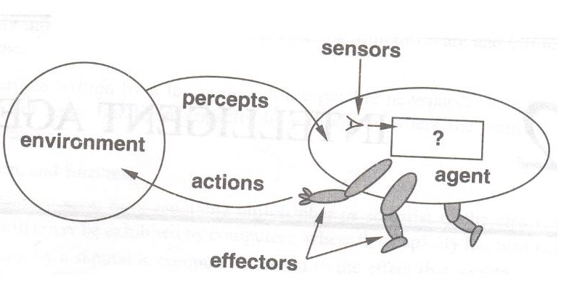

structure in AI

The field of artificial intelligence (AI) includes a wide variety of techniques and approaches that can be used to solve different types of problems. Here are some of the key structures or components of AI:

1. Knowledge Representation: Knowledge representation is the process of representing information in a form that can be processed by an AI system. This can include symbolic representations, such as logical statements or semantic networks, as well as numerical representations, such as vectors or matrices.
2. Inference: Inference is the process of using knowledge and reasoning to draw conclusions or make predictions. This can include deductive reasoning, in which conclusions follow logically from a set of premises, as well as inductive reasoning, which involves making generalizations based on observations or data.
3. Search and Optimization: Search and optimization techniques are used to find solutions to problems that involve exploring a large search space of possible solutions. This can include algorithms like depth-first search, breadth-first search, and hill-climbing, as well as more advanced optimization techniques like genetic algorithms or simulated annealing.
4. Machine Learning: Machine learning is a set of techniques that enable AI systems to learn from data and improve their performance over time. This can include supervised learning, unsupervised learning, and reinforcement learning.
5. Natural Language Processing: Natural language processing (NLP) is a subfield of AI that focuses on enabling machines to understand, interpret, and generate human language. This includes techniques like parsing, semantic analysis, and sentiment analysis.
6. Computer Vision: Computer vision is a subfield of AI that focuses on enabling machines to interpret and understand visual information from the world around them. This can include techniques like image recognition, object detection, and image segmentation.

Overall, the structure of AI involves a wide variety of techniques and approaches, each of which can be used to solve different types of problems. As AI continues to advance, we can expect to see new and more sophisticated techniques being developed that will enable machines to solve increasingly complex and challenging problems.

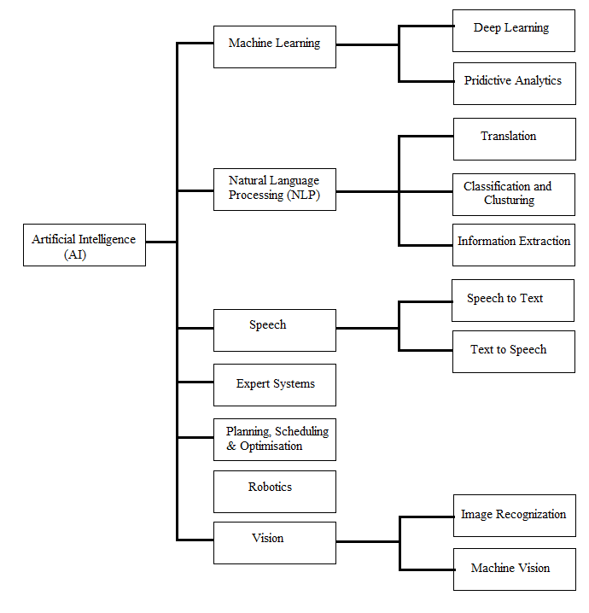

environment in AI

In the field of artificial intelligence (AI), an environment refers to the external context in which an AI agent operates. An environment can be physical, virtual, or a combination of both, and can include a wide range of sensory inputs and outputs.

The environment provides the AI agent with information about the world and allows it to interact with its surroundings. The type of environment can influence the behavior of the AI agent and the types of tasks it can perform. Here are some examples of different types of environments in AI:

1. Physical environment: A physical environment is a real-world environment that an AI agent interacts with through sensors and actuators. Examples include robots operating in a factory or autonomous vehicles driving on the road.
2. Virtual environment: A virtual environment is a simulated environment that an AI agent interacts with through a computer program. Examples include video games, virtual reality simulations, and training simulations for aircraft pilots or military personnel.
3. Mixed environment: A mixed environment is a combination of physical and virtual environments, where an AI agent interacts with both real-world objects and virtual elements. Examples include augmented reality applications that overlay virtual information on the physical world.
4. Open environment: An open environment is one in which the AI agent operates without any pre-defined constraints. This can be more challenging for AI agents because they must adapt to changing conditions and deal with uncertainty.
5. Closed environment: A closed environment is one in which the AI agent operates within a defined set of rules and constraints. This can make it easier to design and train AI agents because the rules are known and can be programmed into the system.

Understanding the environment in which an AI agent operates is critical for developing effective AI systems that can perform well in a wide range of tasks and situations. By designing AI agents that can interact with the world around them, we can develop systems that are more flexible, adaptive, and capable of performing complex tasks.

Configuration and Planning Problems in AI

Configuration and planning problems are common types of problems in artificial intelligence (AI) that involve finding optimal solutions to complex tasks by selecting and arranging elements or actions in a specific way. Here's a brief overview of configuration and planning problems in AI:

1. Configuration problems: Configuration problems involve selecting and arranging elements or objects in a specific way to achieve a particular goal. These problems often involve constraints, such as limited resources or specific rules that must be followed. Examples of configuration problems include scheduling employees, assigning resources to tasks, or designing a circuit board layout.
2. Planning problems: Planning problems involve finding a sequence of actions to achieve a particular goal. These problems can be broken down into subproblems, such as deciding which actions to take, in what order, and how to handle any uncertainties that may arise. Examples of planning problems include scheduling deliveries, planning a route for a self-driving car, or developing a treatment plan for a medical condition.

To solve configuration and planning problems, AI systems often use search algorithms or optimization techniques to explore the space of possible solutions and find the optimal solution that satisfies the given constraints or achieves the desired goal. Machine learning techniques can also be used to train AI systems to recognize patterns and make predictions about how to solve similar problems in the future.

Overall, configuration and planning problems are important challenges in AI that require creative problem-solving and a deep understanding of the underlying domain. As AI technologies continue to advance, we can expect to see more sophisticated techniques being developed that will enable machines to solve increasingly complex configuration and planning problems.

State space representation

In artificial intelligence (AI), state space representation is a way to represent the possible states of a system and the transitions between those states. The system can be anything from a simple game to a complex industrial process, and the state space representation is used to model the behavior of the system and to find optimal solutions to problems.

The state space is defined as a set of all possible configurations or situations of the system. The transitions between states are represented by actions that can be taken to move from one state to another. The state space representation can be represented graphically using a state diagram or state transition diagram, which shows the states and the possible transitions between them.

State space representation is used in various AI techniques, such as search algorithms, planning, and reinforcement learning. In search algorithms, the state space representation is used to find the shortest path or optimal solution to a problem. In planning, the state space representation is used to find a sequence of actions to reach a goal state. In reinforcement learning, the state space representation is used to define the state of the environment and the reward associated with different states.

One of the advantages of state space representation is that it can help break down complex problems into smaller, more manageable sub-problems. By defining the possible states and transitions between them, AI systems can focus on finding the optimal solution for each sub-problem, which can then be combined to solve the overall problem.

Overall, state space representation is a powerful tool for modeling complex systems and finding optimal solutions to problems in artificial intelligence. By defining the state space and the transitions between states, AI systems can effectively reason about the behavior of the system and find efficient ways to achieve desired goals.

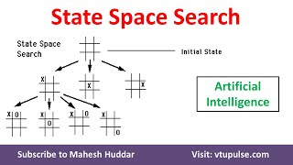

Breadth-first search in AI

Breadth-first search is a popular search algorithm used in artificial intelligence (AI) to explore the state space of a problem by examining all possible paths from the initial state to the goal state. The algorithm starts at the initial state and explores all the neighboring states at the same depth level before moving on to the next level of states.

Here's a brief overview of how breadth-first search works in AI:

1. Start at the initial state: The algorithm starts at the initial state of the problem.
2. Generate all neighboring states: The algorithm generates all the neighboring states at the same depth level.
3. Explore neighboring states: The algorithm explores all the neighboring states at the same depth level before moving on to the next level of states.
4. Mark visited states: The algorithm marks each state that it has visited to ensure that it does not revisit that state again.
5. Check for goal state: The algorithm checks whether the current state is the goal state. If it is, the algorithm terminates and returns the path to the goal state.
6. Repeat: The algorithm repeats steps 2 to 5 for each level of states until the goal state is found or all states have been explored.

Breadth-first search is a complete search algorithm, meaning that it will find a solution if one exists. It is also guaranteed to find the shortest path to the goal state, assuming all actions have the same cost. However, it can be computationally expensive and memory-intensive, especially for problems with a large state space.

Overall, breadth-first search is a useful algorithm for exploring the state space of a problem in AI. By systematically exploring all possible paths from the initial state to the goal state, the algorithm can find an optimal solution that meets the problem constraints.

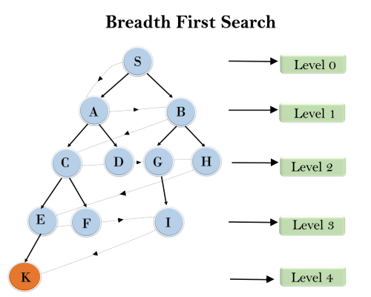

uniform cost search in AI

Uniform cost search is a popular search algorithm used in artificial intelligence (AI) to explore the state space of a problem by considering the cost of each path from the initial state to the goal state. The algorithm starts at the initial state and expands the path with the lowest cost at each iteration until the goal state is found.

Here's a brief overview of how uniform cost search works in AI:

1. Start at the initial state: The algorithm starts at the initial state of the problem.
2. Generate all neighboring states: The algorithm generates all the neighboring states from the current state.
3. Compute the cost of each path: The algorithm computes the cost of each path from the initial state to the neighboring states.
4. Expand the lowest cost path: The algorithm expands the path with the lowest cost and adds it to the list of explored paths.
5. Check for goal state: The algorithm checks whether the current state is the goal state. If it is, the algorithm terminates and returns the path to the goal state.
6. Repeat: The algorithm repeats steps 2 to 5 until the goal state is found or all paths have been explored.

Uniform cost search is an optimal search algorithm, meaning that it will find the optimal solution with the lowest cost. However, it can be computationally expensive and memory-intensive, especially for problems with a large state space or complex cost functions.

Overall, uniform cost search is a useful algorithm for exploring the state space of a problem in AI. By considering the cost of each path from the initial state to the goal state, the algorithm can find an optimal solution that meets the problem constraints.

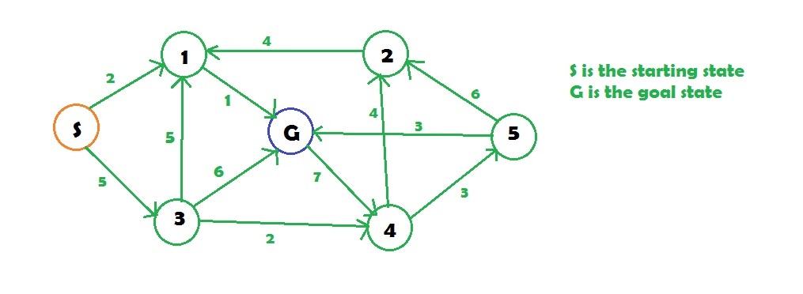

depth-first search in AI

Depth-first search is a popular search algorithm used in artificial intelligence (AI) to explore the state space of a problem by examining one path from the initial state to the goal state at a time. The algorithm starts at the initial state and explores the first neighboring state until it reaches a dead end or the goal state, then backtracks to the next unexplored neighboring state and repeats the process until the goal state is found.

Here's a brief overview of how depth-first search works in AI:

1. Start at the initial state: The algorithm starts at the initial state of the problem.
2. Generate the first neighboring state: The algorithm generates the first neighboring state from the current state.
3. Explore neighboring states: The algorithm explores the first neighboring state until it reaches a dead end or the goal state.
4. Backtrack: The algorithm backtracks to the next unexplored neighboring state and repeats the process until the goal state is found or all paths have been explored.

Depth-first search is often used when the goal state is close to the initial state, as it can quickly find a solution by exploring a single path deeply. However, it may not find the optimal solution, as it only considers one path at a time and may miss shorter paths that exist elsewhere in the state space.

Overall, depth-first search is a useful algorithm for exploring the state space of a problem in AI. By exploring one path deeply before backtracking, the algorithm can quickly find a solution if one exists. However, it may not always find the optimal solution and may be less efficient for problems with a large state space or complex path costs.

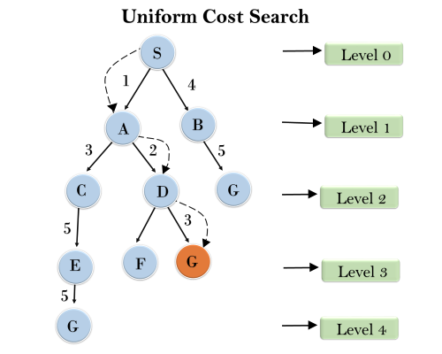

depth-limited search in AI

Depth-limited search is a variant of depth-first search that limits the depth of exploration to a fixed depth level. This can be useful in cases where the depth of the state space is not known in advance, or where the full state space is too large to explore using an unbounded depth-first search algorithm.

Here's a brief overview of how depth-limited search works in AI:

1. Start at the initial state: The algorithm starts at the initial state of the problem.
2. Generate the first neighboring state: The algorithm generates the first neighboring state from the current state.
3. Explore neighboring states up to a fixed depth: The algorithm explores the first neighboring state and recursively applies the same process to its neighboring states up to a fixed depth limit.
4. Backtrack: If the goal state is not found within the fixed depth limit, the algorithm backtracks to the previous state and continues exploring other paths at the same depth level.
5. Repeat: The algorithm repeats steps 2 to 4 until the goal state is found or all paths within the depth limit have been explored.

Depth-limited search can be more efficient than an unbounded depth-first search, as it avoids exploring paths that are too deep and unlikely to lead to the goal state. However, it may still miss the optimal solution if the goal state is beyond the depth limit.

Overall, depth-limited search is a useful algorithm for exploring the state space of a problem in AI. By limiting the depth of exploration, the algorithm can efficiently explore the state space while avoiding unnecessary computations.

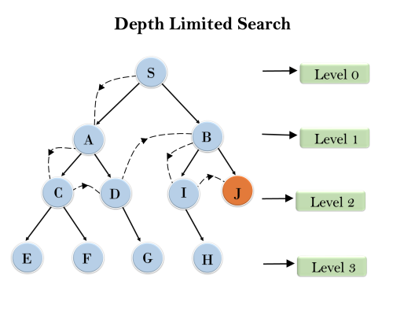

iterative, deepening search DFS

Iterative deepening search (IDS) is a search algorithm that combines the advantages of both breadth-first search (BFS) and depth-first search (DFS) by gradually increasing the depth limit of a depth-limited search until the goal state is found.

Here's a brief overview of how iterative deepening search works in AI:

1. Start at the initial state: The algorithm starts at the initial state of the problem.
2. Set the depth limit to 0: The algorithm sets the depth limit to 0 and performs a depth-limited search up to the depth limit.
3. If the goal state is found, the algorithm returns the solution.
4. Otherwise, increase the depth limit by 1 and repeat steps 2-3 until the goal state is found or the search has explored all paths within a predefined depth limit.

IDS performs a series of depth-limited searches, each with a larger depth limit, until the goal state is found. By gradually increasing the depth limit, IDS can search the state space more efficiently than a traditional DFS while avoiding the memory requirements of BFS.

Iterative deepening search guarantees that it will eventually find a solution, and it finds the shortest path to the goal state, which is the optimal solution, provided that the path cost is a non-decreasing function of the depth of the search.

Overall, iterative deepening search is a useful algorithm for exploring the state space of a problem in AI. It is often used when the depth of the state space is unknown, or the memory resources required for BFS are limited.

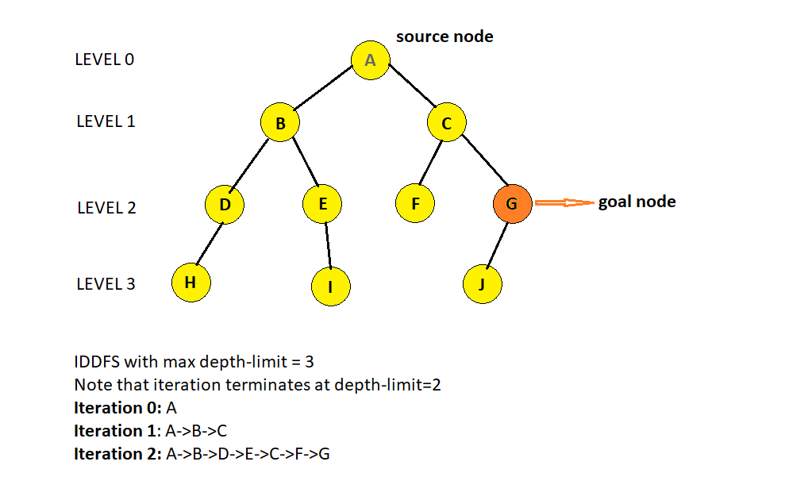

bi-directional search in AI

Bidirectional search is a search algorithm that explores the state space of a problem from both the initial state and the goal state simultaneously, with the aim of meeting in the middle to find a solution more efficiently than unidirectional search algorithms.

Here's a brief overview of how bidirectional search works in AI:

1. Start from both the initial and goal states: The algorithm starts searching from both the initial state and the goal state simultaneously.
2. Generate the first neighboring states: The algorithm generates the first neighboring states from both the initial and goal states.
3. Expand the frontier: The algorithm expands the frontier of the search from both the initial and goal states by exploring the neighboring states and adding them to the corresponding frontiers.
4. Check for meeting points: The algorithm checks for meeting points between the frontiers of the initial and goal states.
5. If a meeting point is found, the algorithm returns the solution.
6. Otherwise, repeat steps 3-5 until the goal state is found or all paths have been explored.

Bidirectional search can be more efficient than unidirectional search algorithms as it explores the state space from both the initial and goal states, reducing the search space and time complexity. However, it requires a way to check if the frontiers from the initial and goal states have met, which can be a challenging problem for some search problems.

Overall, bidirectional search is a useful algorithm for exploring the state space of a problem in AI. By exploring the state space from both the initial and goal states, it can be more efficient than unidirectional search algorithms in finding a solution.

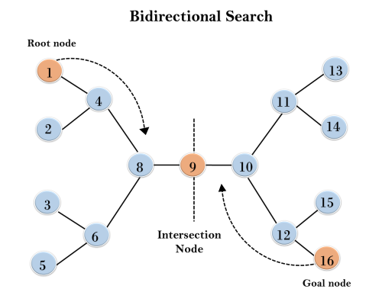

heuristic search technique in AI

Heuristic search is a search technique in AI that uses domain-specific knowledge to guide the search process towards a solution more efficiently. Heuristics are typically functions that estimate the distance or cost to the goal state based on some features of the current state, allowing the search algorithm to prioritize the exploration of more promising paths in the state space.

Here are some common heuristic search techniques in AI:

1. A\* search: A\* search is a popular heuristic search algorithm that combines the use of heuristics with uniform cost search. A\* search uses an evaluation function that combines the cost of the path from the start state to the current state with an estimate of the cost to the goal state. By prioritizing the exploration of states with lower evaluation functions, A\* search can efficiently explore the state space and find optimal solutions.
2. Greedy search: Greedy search is a heuristic search algorithm that prioritizes the exploration of states that appear to be closest to the goal state based on a heuristic function. Greedy search can be more efficient than other search algorithms, but it may not always find the optimal solution.
3. Hill climbing search: Hill climbing search is a heuristic search algorithm that starts from an initial state and iteratively improves the solution by selecting the neighboring state with the highest heuristic value. Hill climbing search can be efficient in finding local maxima, but it may not always find the global maximum.
4. Simulated annealing: Simulated annealing is a heuristic search algorithm that starts from an initial state and gradually explores the state space by allowing some "bad" moves based on a probability distribution. This allows the algorithm to avoid getting stuck in local maxima and find more optimal solutions.

Overall, heuristic search techniques are useful in AI for exploring the state space of a problem more efficiently and finding optimal or near-optimal solutions. By incorporating domain-specific knowledge into the search process, heuristic search algorithms can prioritize the exploration of more promising paths and avoid unnecessary computations.

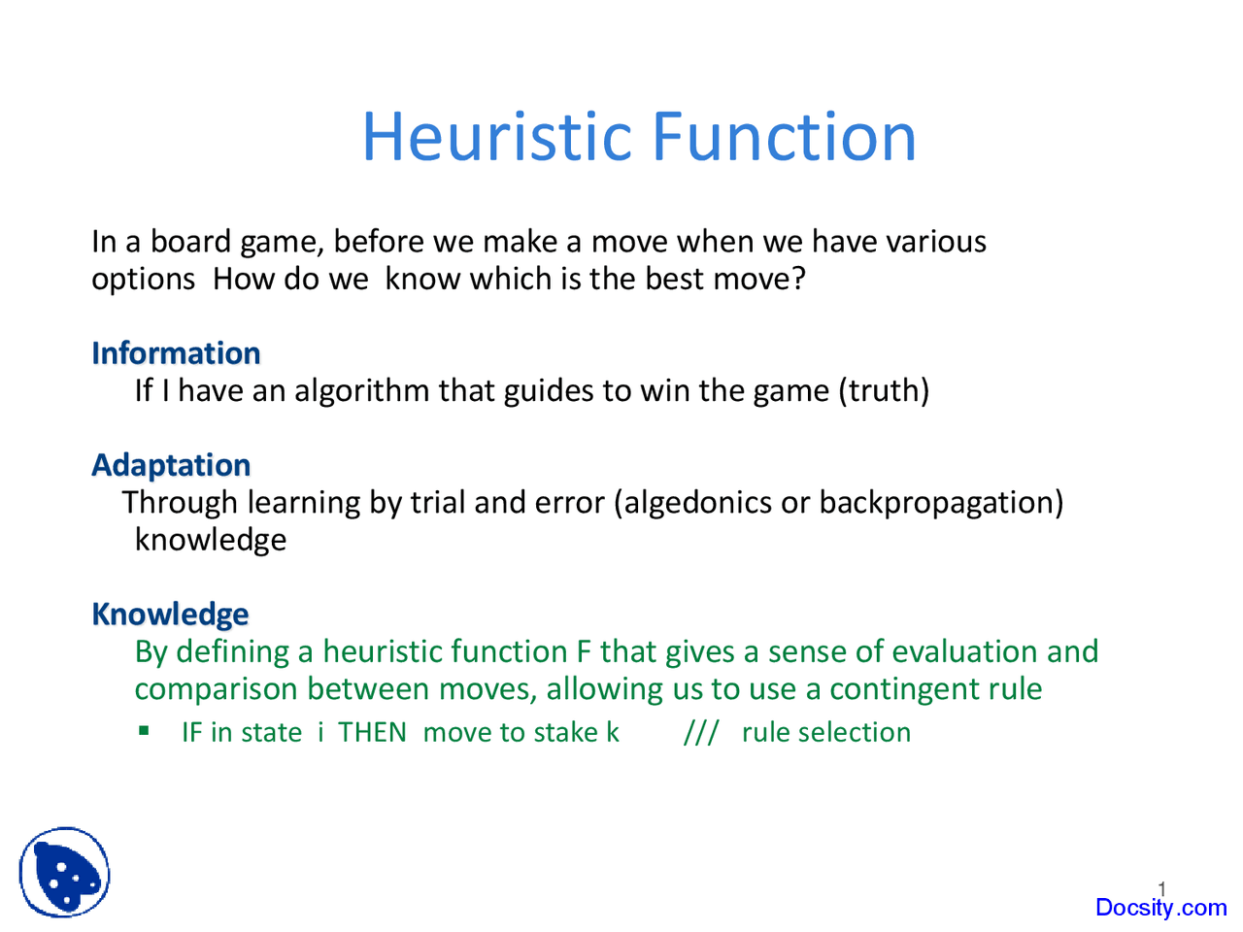

comparing search strategies in AI

In AI, there are several search strategies that can be used to explore the state space of a problem and find a solution. Here are some common search strategies and their strengths and weaknesses:

1. Breadth-first search (BFS): BFS explores the state space by expanding all the neighboring states of the current state before moving on to the next level of the search tree. BFS guarantees that the shortest path to the goal state will be found if the path cost is non-negative. However, BFS can be memory-intensive and may not be efficient in finding a solution if the state space is large.
2. Depth-first search (DFS): DFS explores the state space by traversing as far as possible along each branch before backtracking. DFS can be more memory-efficient than BFS and may be efficient in finding a solution if the path to the goal state is deep. However, DFS may not find the shortest path to the goal state and can get stuck in infinite loops.
3. Uniform cost search (UCS): UCS expands the state with the lowest path cost from the start state. UCS guarantees that the optimal path to the goal state will be found if the path cost is non-negative. However, UCS can be slow if the path cost is large and may not be memory-efficient.
4. A\* search: A\* search combines the use of heuristics with uniform cost search to prioritize the exploration of states with lower evaluation functions. A\* search can be efficient in finding optimal solutions and is often used in practice. However, the quality of the solution depends on the quality of the heuristic function.
5. Iterative deepening search (IDS): IDS is a combination of DFS and BFS that performs DFS up to a certain depth limit and then gradually increases the depth limit until a solution is found. IDS can be memory-efficient and guarantees that the shortest path to the goal state will be found if the path cost is non-negative. However, IDS may be slower than other search algorithms and may not be efficient in finding a solution if the path to the goal state is deep.
6. Bidirectional search: Bidirectional search explores the state space from both the initial and goal states simultaneously and can be more efficient than unidirectional search algorithms in finding a solution. However, bidirectional search requires a way to check if the frontiers from the initial and goal states have met, which can be a challenging problem for some search problems.

Overall, the choice of search strategy depends on the characteristics of the problem, such as the size of the state space, the path cost, and the quality of the heuristic function. Different search strategies have their strengths and weaknesses, and the choice of search strategy can have a significant impact on the efficiency and quality of the solution.

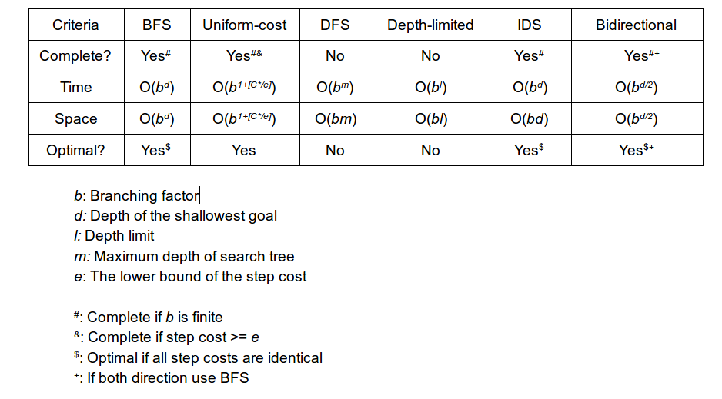

Knowledge, Logic and Reasoning in AI

Knowledge, logic, and reasoning are fundamental components of artificial intelligence (AI) that enable machines to process information, make decisions, and perform tasks. Here's a brief overview of each of these components in AI:

1. Knowledge: Knowledge refers to the information that machines use to represent and understand the world. In AI, knowledge can be represented in various ways, including rules, facts, and concepts. Knowledge-based systems use this knowledge to perform tasks and make decisions based on the available information.
2. Logic: Logic is a formal system of reasoning that allows machines to draw conclusions based on a set of rules or principles. In AI, logic is used to represent and manipulate knowledge using a logical language. Logic-based systems use inference rules to deduce new information from the available knowledge and derive conclusions.
3. Reasoning: Reasoning is the process of using logic to derive conclusions from available information. In AI, reasoning can be used to solve problems, answer questions, and make decisions based on the available knowledge. Reasoning can be performed using different techniques, such as deduction, induction, and abduction, depending on the problem domain.

Some common AI techniques that use knowledge, logic, and reasoning include:

1. Expert systems: Expert systems are AI systems that use knowledge and reasoning to solve problems in a specific domain. Expert systems can represent expert knowledge using rules or other knowledge representation techniques and use inference mechanisms to solve problems.
2. Automated reasoning: Automated reasoning is the process of using logic and reasoning to automatically prove or disprove a statement. Automated reasoning can be used in various applications, such as theorem proving, program verification, and diagnosis.
3. Natural language processing (NLP): NLP is an AI technique that enables machines to understand and generate human language. NLP systems use knowledge and reasoning to parse and interpret natural language texts and generate responses.

Overall, knowledge, logic, and reasoning are essential components of AI that enable machines to represent, understand, and manipulate information to perform tasks and make decisions. AI systems that use these techniques can be applied in various domains, including healthcare, finance, and education, among others.

Propositional logic in AI

Propositional logic is a fundamental component of artificial intelligence (AI) that allows machines to represent and manipulate knowledge using logical statements. Propositional logic, also known as sentential logic, is a formal system of reasoning that deals with propositions or statements that can be either true or false.

In propositional logic, knowledge is represented using logical symbols and operators. The logical symbols represent propositions or statements, while the logical operators define the relationships between the propositions. The most common logical operators used in propositional logic are:

1. Negation: ¬ (not)
2. Conjunction: ∧ (and)
3. Disjunction: ∨ (or)
4. Implication: → (if-then)
5. Equivalence: ↔ (if and only if)

Using these logical operators, complex propositions can be constructed by combining simpler propositions. For example, the proposition "It is raining and the sun is shining" can be represented using the conjunction operator as "rain ∧ sun".

Propositional logic is used in many AI applications, including knowledge representation, automated reasoning, and natural language processing. In knowledge representation, propositional logic is used to represent knowledge about the world in a structured and formal way. In automated reasoning, propositional logic is used to prove or disprove logical statements and derive new knowledge from existing knowledge. In natural language processing, propositional logic is used to represent the meaning of natural language sentences and enable machines to understand and generate human language.

Overall, propositional logic is a powerful tool for representing and manipulating knowledge in AI. Its simplicity and formalism make it an essential component of many AI techniques and applications.

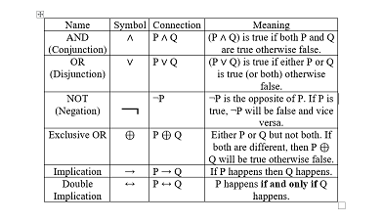

predicate logic in AI

Predicate logic, also known as first-order logic, is a more expressive and powerful logical system than propositional logic, which is used in artificial intelligence (AI) for representing and reasoning about complex relationships between objects and concepts. In predicate logic, propositions are represented using predicates, which are functions that take one or more arguments and return a truth value.

Predicate logic allows for more complex statements and relationships between objects and concepts to be represented. For example, in propositional logic, the statement "All dogs bark" would have to be represented as a single proposition, whereas in predicate logic it can be represented as a predicate "Barks(x)" with a variable "x" representing the dog. This allows for more complex relationships to be expressed, such as "All dogs bark, but not all animals that bark are dogs."

Predicate logic includes several important features that make it useful for AI applications, including:

1. Variables: Predicate logic uses variables to represent objects or entities. These variables can be used to express general relationships between objects or to make statements about specific objects.
2. Quantifiers: Predicate logic includes two types of quantifiers, universal quantifiers (∀) and existential quantifiers (∃). These quantifiers allow for statements about all objects in a domain or some objects in a domain, respectively.
3. Functions: Predicate logic includes functions, which can be used to express relationships between objects. For example, a function could be used to represent the parent-child relationship between two objects.

Predicate logic is used in many AI applications, including knowledge representation, automated reasoning, and natural language processing. In knowledge representation, predicate logic is used to represent complex relationships between objects and concepts. In automated reasoning, predicate logic is used to make deductions and inferences based on the available knowledge. In natural language processing, predicate logic is used to represent the meaning of natural language sentences and enable machines to understand and generate human language.

Overall, predicate logic is a powerful tool for representing and reasoning about complex relationships in AI. Its expressiveness and formalism make it an essential component of many AI techniques and applications.

The first Order Predicate Logic

First-order predicate logic, also known as first-order logic or first-order predicate calculus, is a formal system of mathematical logic used in artificial intelligence (AI) and computer science to represent and reason about relationships between objects and concepts.

First-order predicate logic extends propositional logic by allowing for the representation of relationships between objects and concepts using predicates and variables. In first-order predicate logic, predicates are functions that take one or more arguments and return a truth value. Variables are used to represent objects or entities, and they can be bound to values or to other variables using quantifiers.

First-order predicate logic includes several important features, including:

1. Variables: Variables are used to represent objects or entities. These variables can be used to express general relationships between objects or to make statements about specific objects.
2. Predicates: Predicates are functions that take one or more arguments and return a truth value. They are used to represent relationships between objects and concepts.
3. Quantifiers: First-order predicate logic includes two types of quantifiers, universal quantifiers (∀) and existential quantifiers (∃). These quantifiers allow for statements about all objects in a domain or some objects in a domain, respectively.
4. Connectives: First-order predicate logic includes logical connectives such as conjunction (∧), disjunction (∨), implication (→), and negation (¬), which allow for the construction of complex statements.

First-order predicate logic is used in many AI applications, including knowledge representation, automated reasoning, and natural language processing. In knowledge representation, first-order predicate logic is used to represent complex relationships between objects and concepts. In automated reasoning, first-order predicate logic is used to make deductions and inferences based on the available knowledge. In natural language processing, first-order predicate logic is used to represent the meaning of natural language sentences and enable machines to understand and generate human language.

Overall, first-order predicate logic is a powerful tool for representing and reasoning about complex relationships in AI. Its expressiveness and formalism make it an essential component of many AI techniques and applications.

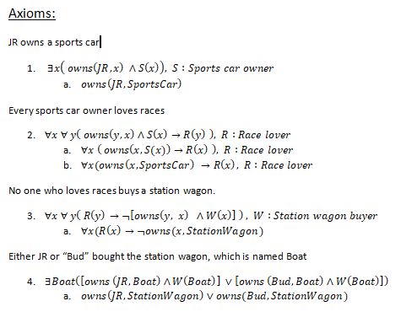

The Universal Quantifier

The universal quantifier is a logical quantifier used in predicate logic to express statements that apply to all elements in a given domain. The symbol used to represent the universal quantifier is ∀ (read as "for all" or "for every").

In predicate logic, a statement involving the universal quantifier is of the form ∀xP(x), where P(x) is a predicate that depends on the variable x. This statement asserts that the predicate P(x) is true for every value of x in the domain.

For example, the statement "All cats have fur" can be expressed in predicate logic as ∀x(Cat(x) → HasFur(x)), where Cat(x) and HasFur(x) are predicates representing the concepts of being a cat and having fur, respectively.

The universal quantifier can also be used to define sets or collections of elements that satisfy a given property. For example, the set of all integers greater than 0 can be defined as {x | ∀y(y>0 → x>y)}.

In artificial intelligence (AI), the universal quantifier is used in many applications, including knowledge representation, automated reasoning, and natural language processing. In knowledge representation, the universal quantifier is used to express general statements about a domain of discourse. In automated reasoning, the universal quantifier is used to make deductions and inferences based on the available knowledge. In natural language processing, the universal quantifier is used to represent the meaning of natural language sentences and enable machines to understand and generate human language.

Overall, the universal quantifier is an important tool in predicate logic and plays a critical role in many AI applications.

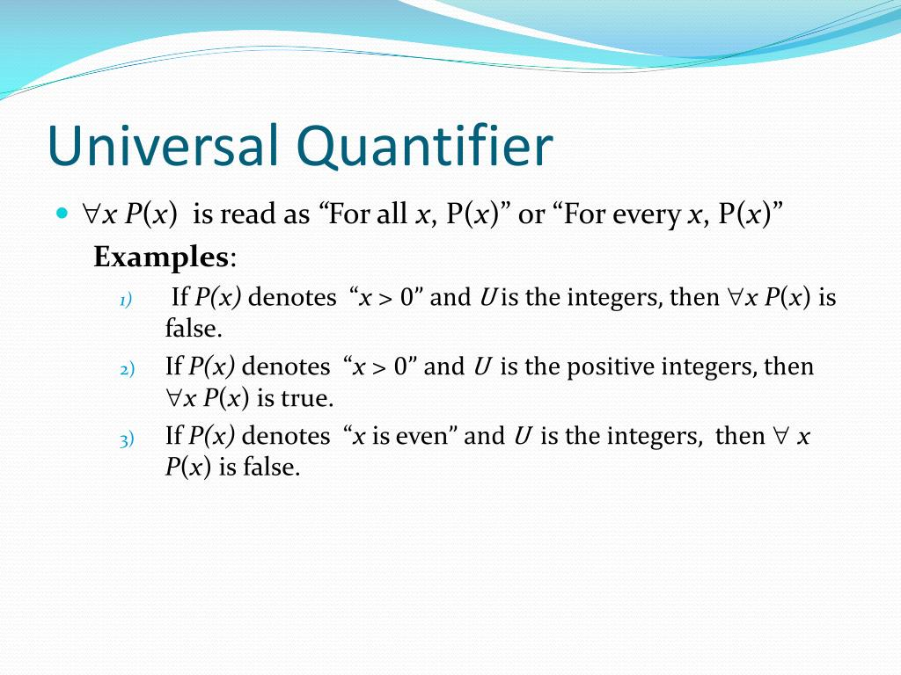

The Existential Quantifier

The existential quantifier is a logical quantifier used in predicate logic to express statements that apply to at least one element in a given domain. The symbol used to represent the existential quantifier is ∃ (read as "there exists").

In predicate logic, a statement involving the existential quantifier is of the form ∃xP(x), where P(x) is a predicate that depends on the variable x. This statement asserts that there exists at least one value of x in the domain for which the predicate P(x) is true.

For example, the statement "There exists a cat with black fur" can be expressed in predicate logic as ∃x(Cat(x) ∧ BlackFur(x)), where Cat(x) and BlackFur(x) are predicates representing the concepts of being a cat and having black fur, respectively.

The existential quantifier can also be used to define sets or collections of elements that satisfy a given property. For example, the set of all odd integers can be defined as {x | ∃y(x=2y+1)}.

In artificial intelligence (AI), the existential quantifier is used in many applications, including knowledge representation, automated reasoning, and natural language processing. In knowledge representation, the existential quantifier is used to express specific statements about a domain of discourse. In automated reasoning, the existential quantifier is used to make deductions and inferences based on the available knowledge. In natural language processing, the existential quantifier is used to represent the meaning of natural language sentences and enable machines to understand and generate human language.

Overall, the existential quantifier is an important tool in predicate logic and plays a critical role in many AI applications.

